# **Year & Branch: TY ETC Subject: Web Technology Subject Code:ET3273**

# **Experiment no: 2**

**Grp -1**

|  |  |  |  |
| --- | --- | --- | --- |
| **Name** | **Roll No.** | **Div** | **GR. No.** |
| Krushna Durole | 62 | A | 12010277 |

# 

**TITLE:** Design static web page to demonstrate the use of different CSS tags.

**AIM:** Understand use of various CSS tags in web pages.

**THEORY**:

CSS can be added to HTML documents in 3 ways:

* **Inline** - by using the style attribute inside HTML elements
* **Internal** - by using a <style> element in the <head> section
* **External** - by using a <link> element to link to an external CSS file

CSS selectors are used to select the HTML elements to style.

* Simple selectors (select elements based on name, id, class)
* [Combinator selectors](https://www.w3schools.com/css/css_combinators.asp) (select elements based on a specific relationship between them)
* [Pseudo-class selectors](https://www.w3schools.com/css/css_pseudo_classes.asp) (select elements based on a certain state)
* [Pseudo-elements selectors](https://www.w3schools.com/css/css_pseudo_elements.asp) (select and style a part of an element)
* [Attribute selectors](https://www.w3schools.com/css/css_attribute_selectors.asp) (select elements based on an attribute or attribute value)

Background Properties

* background - Sets all the background properties in one declaration
* background-attachment - Sets whether a background image is fixed or scrolls with the rest of the page
* background-clip - Specifies the painting area of the background
* background-color - Sets the background color of an element
* background-image - Sets the background image for an element
* background-origin - Specifies where the background image(s) is/are positioned
* background-position - Sets the starting position of a background image
* background-repeat - Sets how a background image will be repeated
* background-size - Specifies the size of the background image(s)

Border Properties

* border - Sets all the border properties in one declaration
* border-bottom - Sets all the bottom border properties in one declaration
* border-bottom-color - Sets the color of the bottom border
* border-bottom-style - Sets the style of the bottom border
* border-bottom-width - Sets the width of the bottom border
* border-color- Sets the color of the four borders
* border-left - Sets all the left border properties in one declaration
* border-left-color - Sets the color of the left border
* border-left-style - Sets the style of the left border
* border-left-width - Sets the width of the left border
* border-radius - Sets all the four border-*-radius properties for rounded corners
* border-right - Sets all the right border properties in one declaration
* border-right-color - Sets the color of the right border
* border-right-style - Sets the style of the right border
* border-right-width - Sets the width of the right border
* border-style - Sets the style of the four borders
* border-top - Sets all the top border properties in one declaration
* border-top-color - Sets the color of the top border
* border-top-style - Sets the style of the top border
* border-top-width - Sets the width of the top border
* border-width - Sets the width of the four borders

Margin Properties

* margin - A shorthand property for setting all the margin properties in one declaration
* margin-bottom - Sets the bottom margin of an element
* margin-left - Sets the left margin of an element
* margin-right - Sets the right margin of an element
* margin-top - Sets the top margin of an element

Padding Properties

* padding - A shorthand property for setting all the padding properties in one declaration
* padding-bottom - Sets the bottom padding of an element
* padding-left - Sets the left padding of an element
* padding-right - Sets the right padding of an element
* padding-top - Sets the top padding of an element
* Dimension Properties
* height - Sets the height of an element
* max-height - Sets the maximum height of an element
* max-width - Sets the maximum width of an element
* min-height - Sets the minimum height of an element
* min-width - Sets the minimum width of an element
* width - Sets the width of an element

Text properties

* direction - Specifies the text direction/writing direction
* text-align - Specifies the horizontal alignment of text
* text-align-last - Specifies how to align the last line of a text
* vertical-align - Sets the vertical alignment of an element
* letter-spacing - Specifies the space between characters in a text
* line-height - Specifies the line height
* text-indent - Specifies the indentation of the first line in a text-block
* white-space - Specifies how to handle white-space inside an element
* word-spacing - Specifies the space between words in a text

Font Properties

* font - Sets all the font properties in one declaration
* font-family - Specifies the font family for text
* font-size - Specifies the font size of text
* font-style - Specifies the font style for text
* font-variant - Specifies whether or not a text should be displayed in a small-caps font
* font-weight - Specifies the weight of a font

Table Properties

* border - Sets all the border properties in one declaration
* border-collapse - Specifies whether or not table borders should be collapsed
* border-spacing - Specifies the distance between the borders of adjacent cells
* caption-side - Specifies the placement of a table caption
* empty-cells - Specifies whether or not to display borders and background on empty cells in a table
* table-layout - Sets the layout algorithm to be used for a table

List Properties

* list-style - Sets all the properties for a list in one declaration
* list-style-image - Specifies an image as the list-item marker
* list-style-position - Specifies the position of the list-item markers (bullet points)
* list-style-type - Specifies the type of list-item marker

**CODE**:

Home

#title{

    text-align: center;

}

p{

    text-align: center;

    background-color: bisque;

}

#title{

    background-color: black;

    color: white;

    border-radius: 20%;

    border-radius: 40%;

   height: 5em;

   vertical-align: middle;

}

.navbar{

    background-color: rgb(71, 19, 19);

    /* height: 5em; */

    text-align: center;

    padding: 1em;

    justify-content: space-evenly;

    justify-content:space-around;

}

a{

    color: white;

}

button{

    border-radius: 50%;

    size: 6em;

    height: 2em;

    width: 12em;

}

.clickhere{

    color: black;

}

#Booksavail{

    height: 3em;

    vertical-align:middle;

    background-color: rgb(164, 230, 230);

Signup

.title{

    text-align: center;

}

a{

    font-family: 'Roboto', sans-serif;

}

.navbar{

    background-color: aliceblue;

    height: 4em;

    text-align: center;

    vertical-align:middle;

    padding-top: 2em;

}

h1,p{

    text-align: center;

}

form{

    text-align: center;

}

Login

.navbar{

    text-align: center;

    justify-content: center;

}

a{

    font-family: 'Roboto', sans-serif;

}

.navbar{

    background-color: aliceblue;

    height: 4em;

    text-align: center;

    vertical-align:middle;

    padding-top: 2em;

}

.hello{

    width: 35em;

}

h2{

    text-align: center;

}

p{

    text-align: center;

}

.form{

    text-align: center;

    border-color: black;

    border-width: 4em;

    border: 4em;

}

Authors

body {

    background-color: rgb(176, 228, 178);

}

h1 {

    color: rgb(14, 2, 24);

    margin-left: 20px;

}

table {

    border-collapse: collapse;

  }

th, td {

    border: 3px solid black;

  }

Book info

body{

    background-image: url(/Lab-2/images/background.jpeg);

    background-size: 100%;

    width:100%;

    height:100%;

}

#footer{

    text-align: center;

    position: fixed;

    bottom: 0;

    width:100%;

    height:50px;

    }

table{

    padding-top: 100px;

    width: 98.5%;

    height: 80%;

    border-collapse: collapse;

}

th {

    background-color: #6400fa;

    color: rgb(253, 253, 253);

    height: 55px;

  }

td{

    height: 50px;

    text-align: center;

    vertical-align: middle;

  }

tr:nth-child(even) {background-color: #eadcf9;}

tr:nth-child(odd) {background-color: rgb(201, 198, 249);}

tr:hover {background-color: #ddd;}

Audio

body{

    /* background-image: url(/images/bg.png); */

    background-color: beige;

    background-size: 100%;

    width:100%;

    height:100%;

}

#footer{

  text-align: center;

  position: fixed;

  bottom: 0;

  width:100%;

  height:50px;

  }

table{

    padding-top: 100px;

    width: 98.5%;

    height: 80%;

    border-collapse: collapse;

    border-radius: 10%;

    border: 1px solid;

}

th {

  background-color: #000000;

  color: rgb(253, 253, 253);

  height: 55px;

  border: 1px solid;

  font-size: large;

  font-style: oblique;

}

td{

  height: 50px;

  text-align: center;

  vertical-align: middle;

  border: 1px solid;

  font-size: large;

}

.navigation {

    /* background-color: rgb(255, 255, 255); */

    background-size: 100%;

    color: white;

    text-align: center;

    display: flex;

    -ms-flex-align: center;

    justify-content: space-evenly;

  }

button{

    width: 110px;

    height: 20px;

    background-color: rgb(255, 255, 255);

    color: white;

  }

  tr:nth-child(even) {background-color: #eadcf9;}

tr:nth-child(odd) {background-color: rgb(201, 198, 249);}

tr:hover {background-color: #ddd;}

# **RESULT:**

**Home Page:**

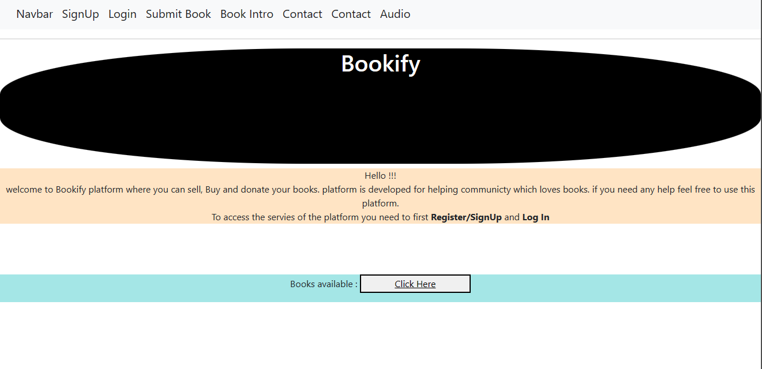

**Login Page:**

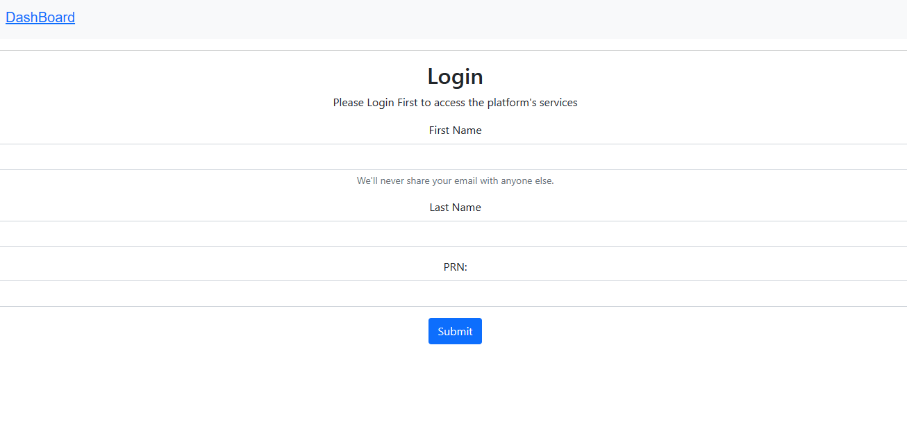

**Signup Page:**

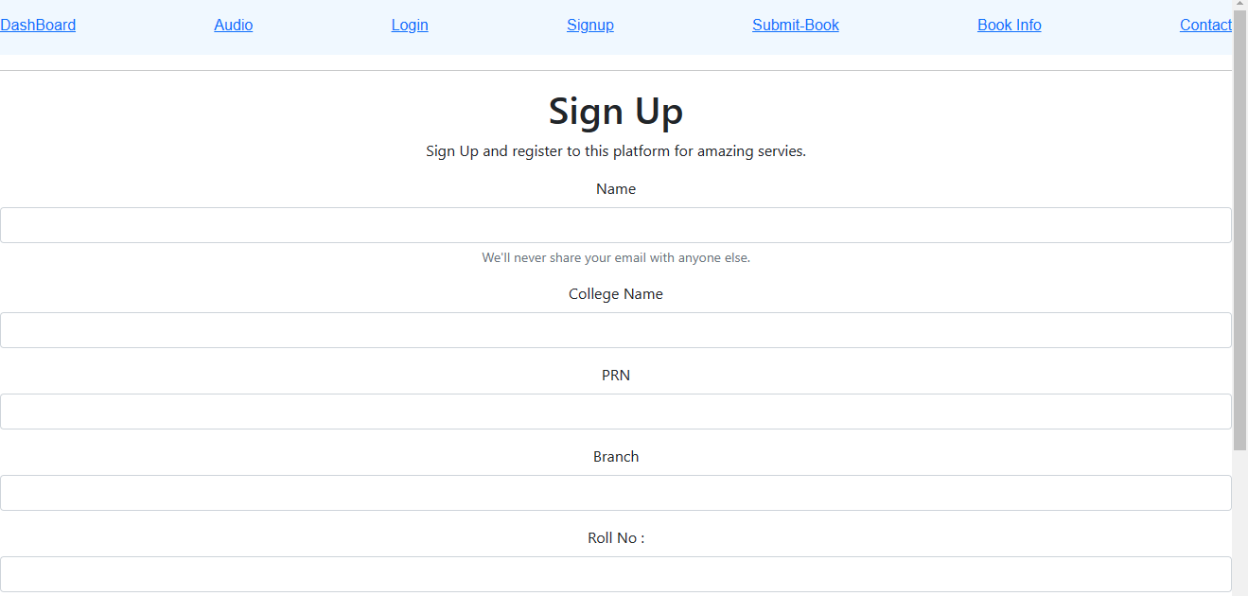

**Book Info:**

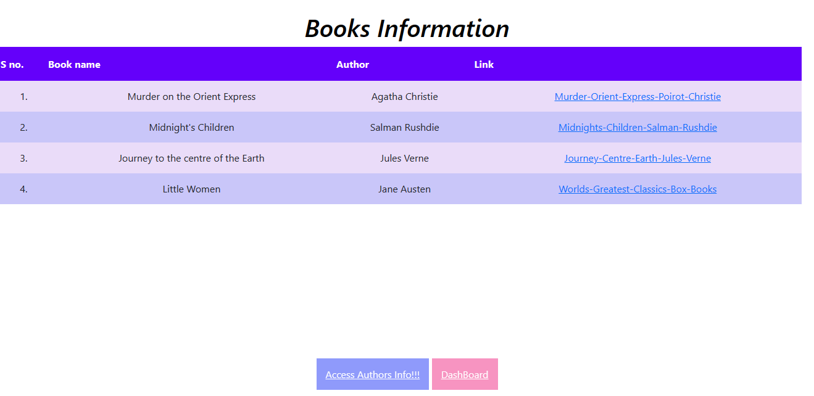

**Submit Book:**

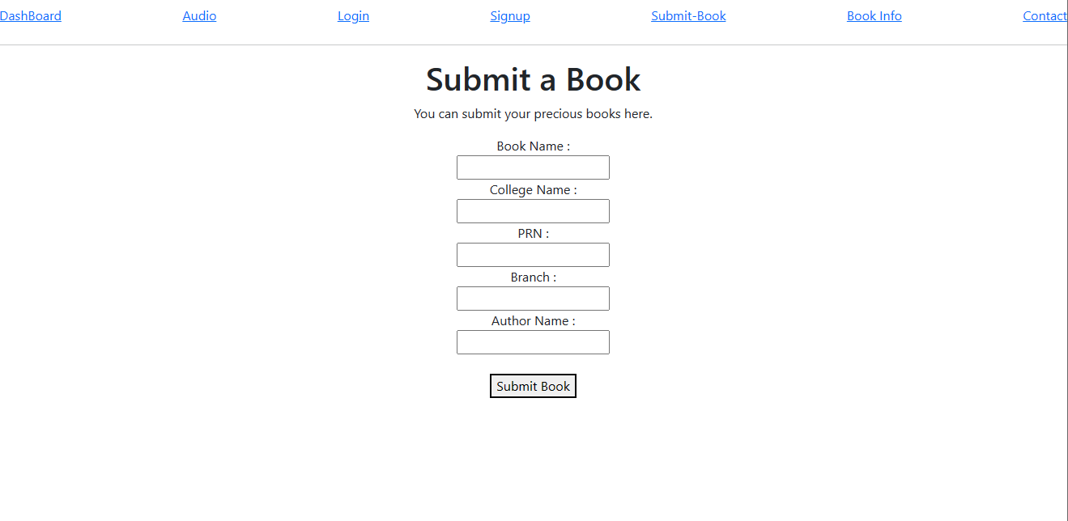

**Authors’ Info:**

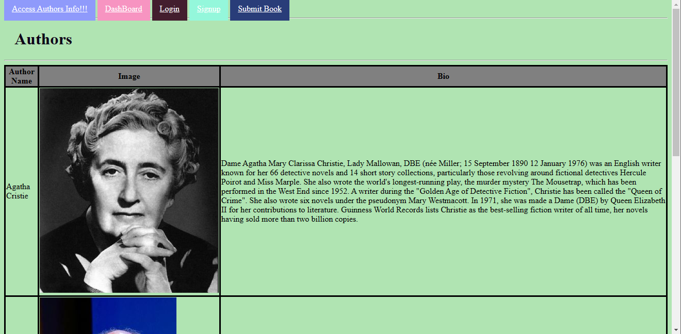

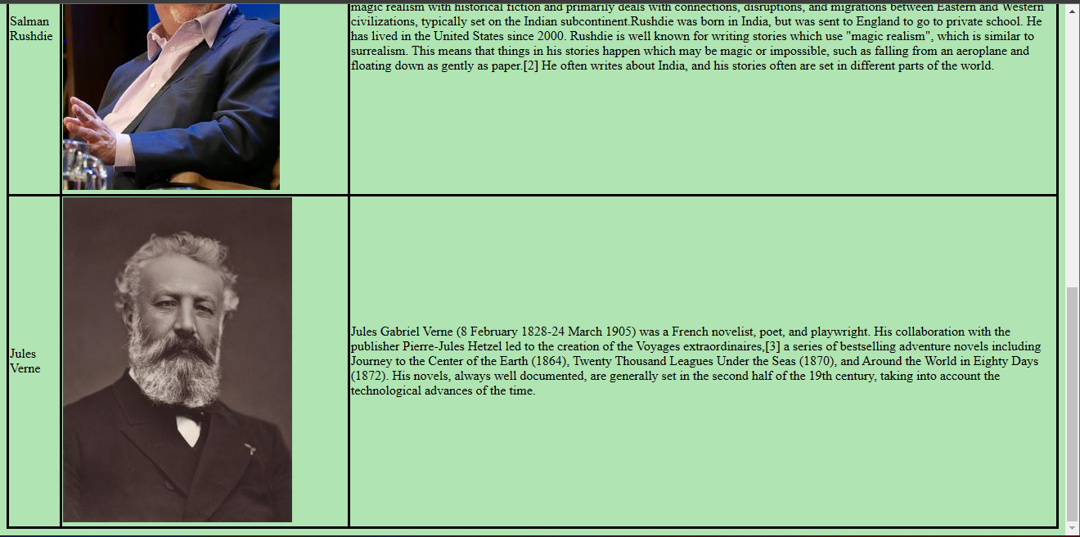

**Audio Books:**

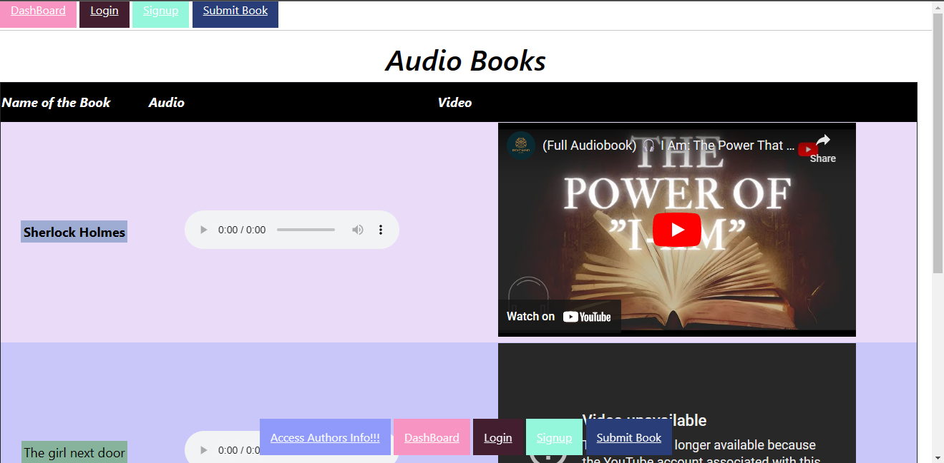

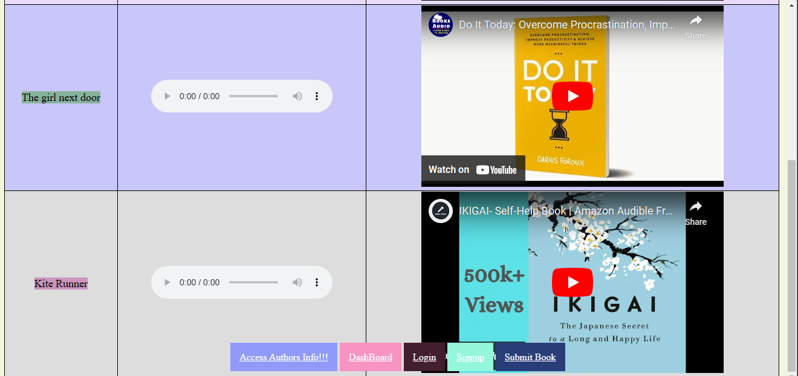

**CONCLUSION:**

CSS is the language for describing the presentation of Web pages, including colors, layout, and fonts. It allows one to adapt the presentation to different types of devices, such as large screens, small screens, or printers. CSS is independent of HTML and can be used with any XML-based markup language.